**Recommendation System for an Online Retailer(Fashion Products)**

1: Data Extraction:

import pandas as pd

# Replace 'path/to/your/dataset.csv' with the actual path or name of your downloaded dataset file

data = pd.read_csv(yourpath//fashion_products.csv')

# Display the first few rows of the dataset to understand its structure

data.info ()

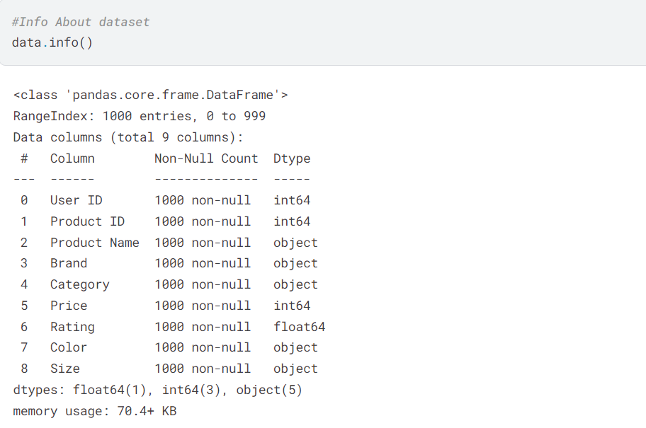

2: Data Storage:

Database Name: REC_ENGINE

Table Name: Retail_Data

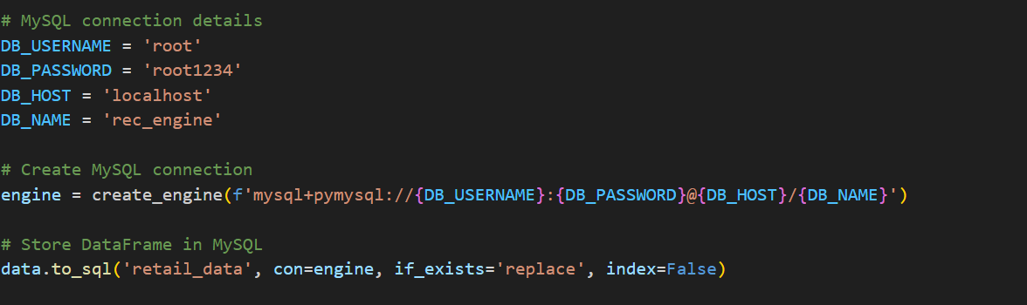

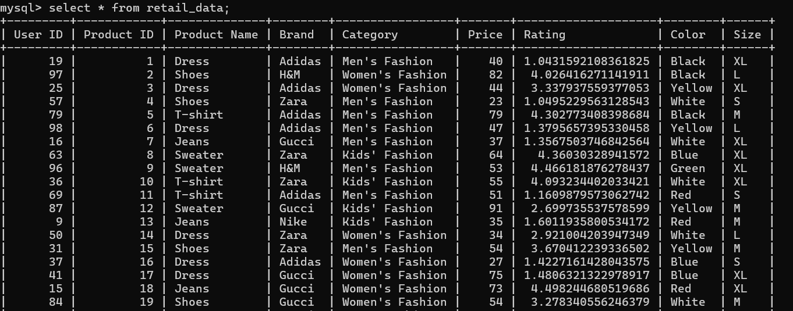

3: Data Cleaning:

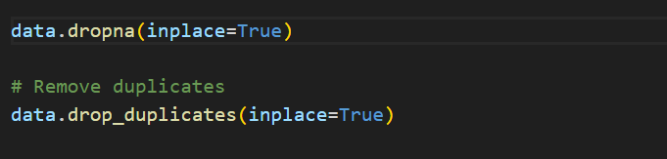

4: Data Transformation:

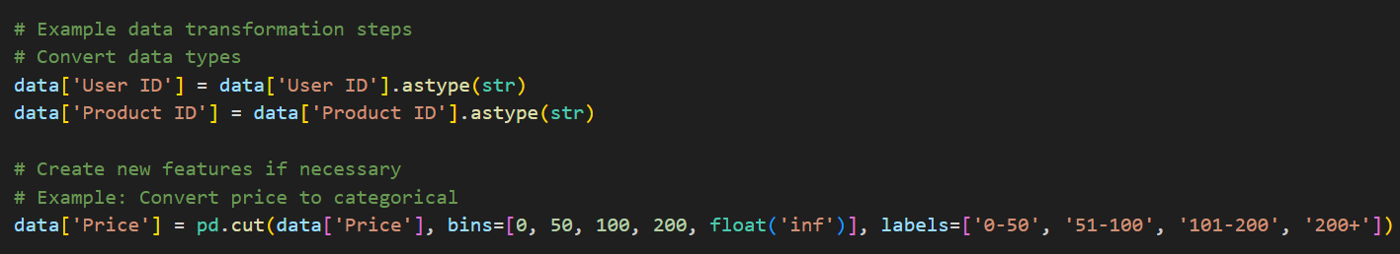

5: Exploratory Data Analysis (EDA):

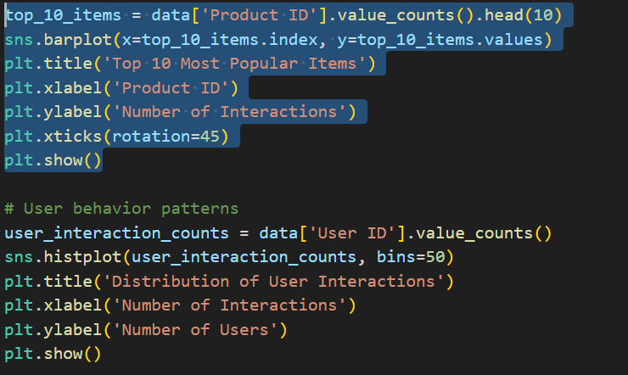

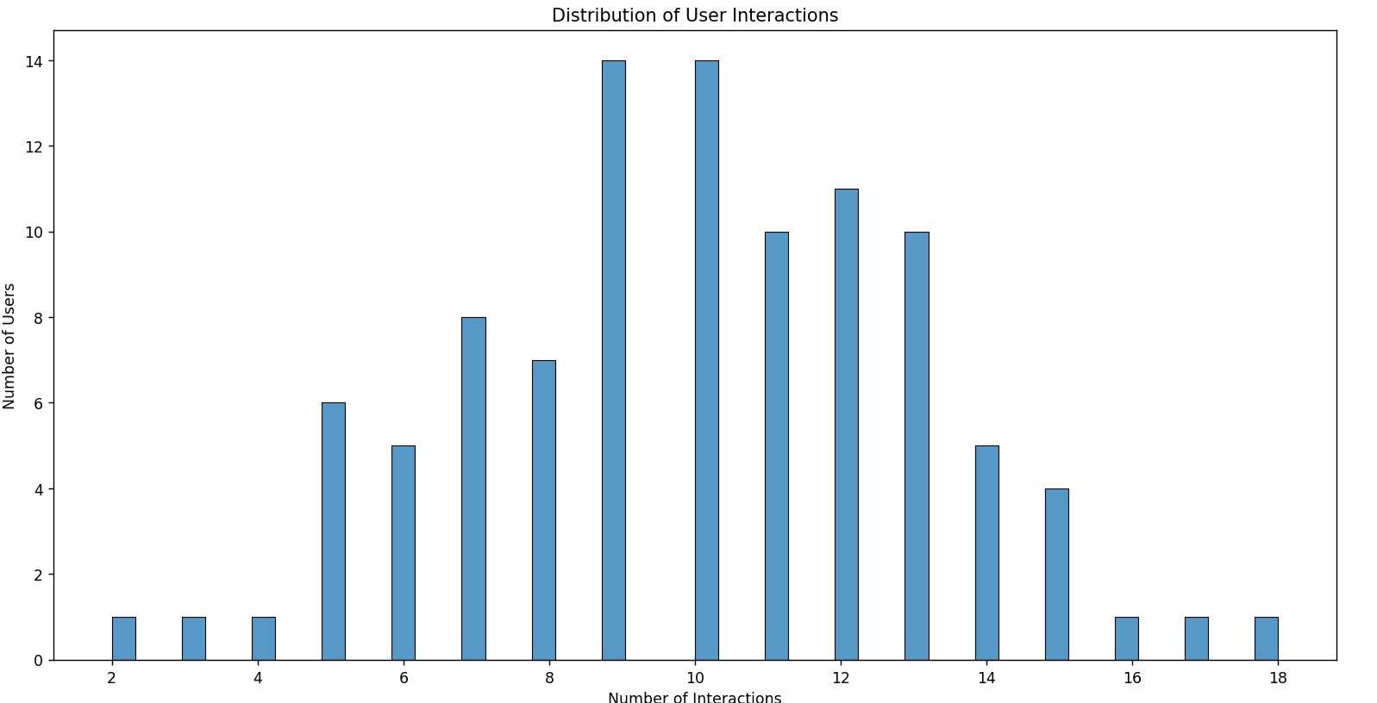

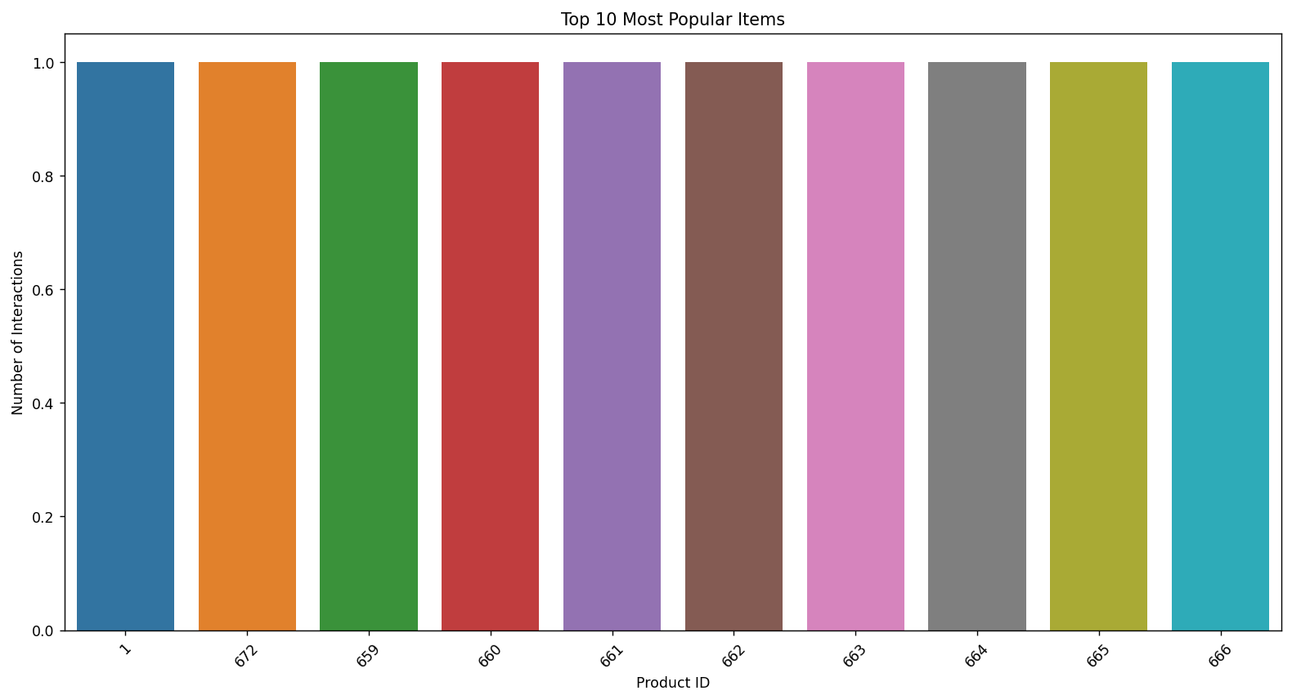

6**:** Recommendation Algorithms:

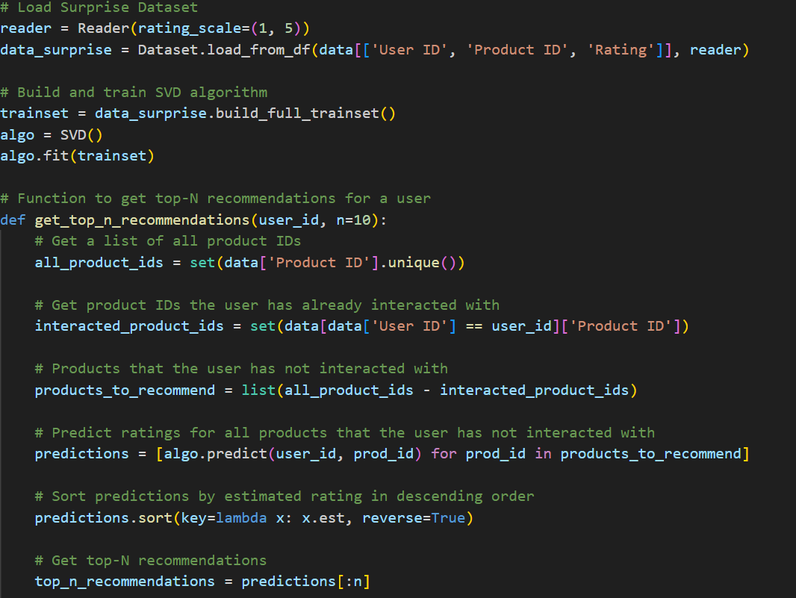

7: Model Evaluation and Deployment:

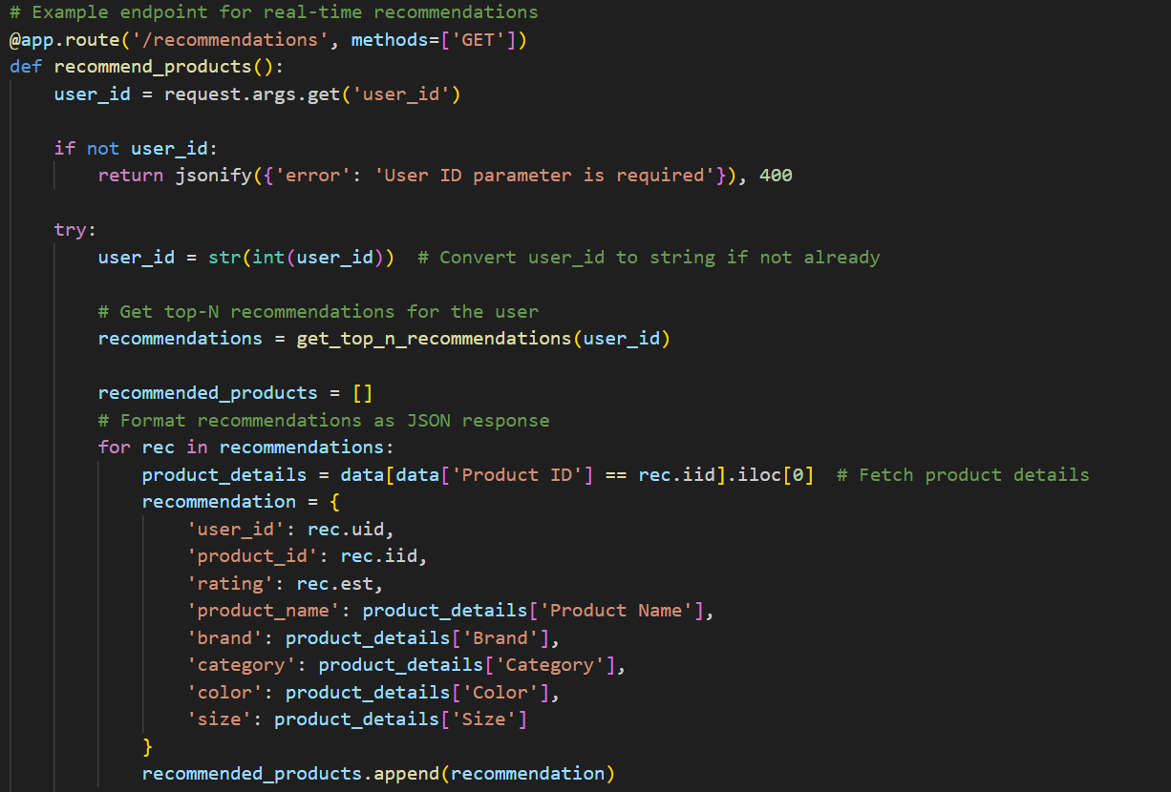

Url : <http://localhost:5000/recommendations?user_id=123>



